

Assignment 1

Documentation



September 22, 2022

Vijay Kumar

Extra Features:

1. **Login Screen: -** A login Page is Displayed at the beginning of the Application start-up. The default username and password are written at the bottom right, to proceed with the application. A Test Case is completed and documented below.

|  |  |  |  |
| --- | --- | --- | --- |
| Requirement to test | Test Data Input | Expected Outcomes | Actual outcomes |
| Display Error Message if Wrong Credentials | - | Application Loads Main form after Login is successful. | The main form loaded when the Application loaded first. |

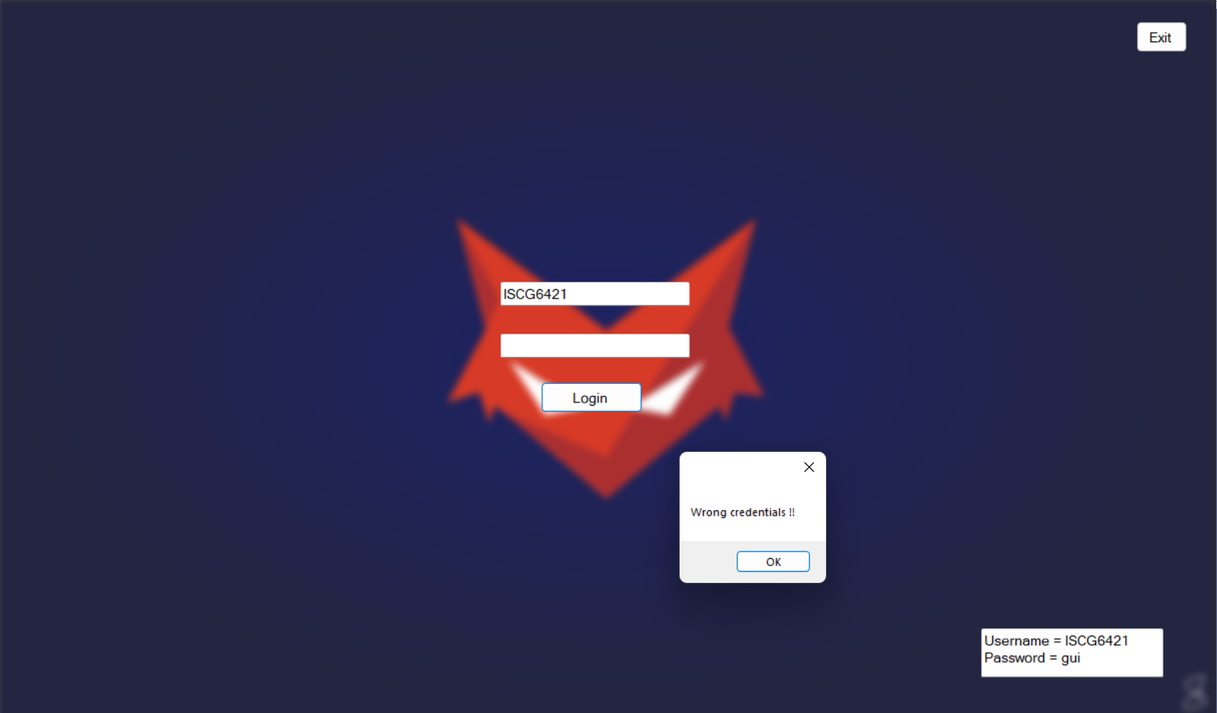

1. **Change Dashboard Wallpaper –** Change the Dashboard wallpaper by clicking the arrow button at the top right of the screen.

Test Cases:

|  |  |  |  |
| --- | --- | --- | --- |
| Requirement to test | Test Data Input | Expected Outcomes | Actual outcomes |
| 1. Application Displays Main Form after Login successful. | - | Application Loads Main form after Login is successful. | The main form loaded when the Application loaded first. |
| 1. Arena Maintenance button. | The user clicks on the Arena Maintenance button. | The arena Maintenance form is loaded. | The Arena Maintenance form is loaded when the user clicks on the Maintenance button. |
| 1. Previous and Next Button on Arena Maintenance form. | User clicks on Previous or Next | The user clicks on Previous and Next and Button to browse through the Arena list and Arena list details are displayed accordingly. | Same as the expected outcome. |
| 1. “Add Arena” Button. | The user clicks on Add Arena Button. | On click, Panel Add Arena is displaced, rest of the buttons are disabled on the Arena Maintenance form. | Same as the expected outcome. |
| 1. Add a New Arena record. | User fill details in opened Panel “Add Arena” | Users fill in details and click on save Arena. A New Arena record is Added. Arena Name is displayed in the list box.  A message box is displayed if the user leaves a blank field. | Same as the expected outcome. |
| 1. Update existing Arena Record. | The user clicks on the Update Arena button on the Arena Maintenance form. | Update Arena Panel is displayed, and information is displayed of selected Arena. The user clicks the save changes button and the Message box displays a message and Arena Panel is closed. | Same as the expected outcome. |
| 1. Delete the Arena record. | The user clicks on the Delete button to delete the selected Arena. | A message box is displayed if Arena has Events Scheduled and delete operation is not performed.  Otherwise, A message box is displayed to confirm the user wants to delete the selected Arena. On click “ok” Arena record is deleted. | Same as the expected outcome. |
| 1. Attempt to mark as finished an existing completed challenge. | The user clicks on the “Mark Challenge as a finished button” | Challenge Status changes to “Finished” | Same as the expected outcome. |
| 1. Attempt to mark as completed an existing scheduled challenge | The user clicks on the “Mark Challenge as a Complete button” | Challenge Status changes to “complete” | Same as the expected outcome. |
|  |  |  |  |
| 1. Add a new challenge with valid data in all fields. | The user enters valid data in all fields. | A new challenge will be added to the Challenge list and a Message is displayed “New challenge is added successfully”. Newly challenge added to the Listbox, details displayed when the user clicks on New challenge added in the Listbox. | Same as expected. |
| 1. Update an existing challenge’s capacity with valid data. | The user changes the capacity of the challenge and clicks on the button “save changes”. | A message is displayed “challenge updated successfully”. changes in capacity are saved and Updated. | Same as expected. |
| 1. Update an existing challenge’s name with valid data. | The user changes the name of the challenge and clicks on the button “save changes”. | A message is displayed “challenge updated successfully”. changes in the challenge name are saved and Updated. | Same as expected. |
| 1. Delete an existing challenge that has no entries. | The user clicks on the delete button to delete the selected challenge in the List Box. | Message Box appears to confirm delete operation, if the user clicks ok, the selected challenge is deleted.  If Challenge has associated entities, an appropriate message is displayed. | Same as expected. |
| 1. Add a new event with valid data in all fields. | The user enters valid data in all fields. | A new Event will be added to the Event list and a Message is displayed “New Event is added successfully”. Newly Event added to the Listbox, details displayed when the user clicks on New Event added in the Listbox. | Same as expected. |
| 1. Update an existing event’s name with valid data. | The user changes the name of the Event and clicks on the button “save changes”. | A message is displayed “Event updated successfully”. changes in the Event name are saved and updated. | Same as expected. |
| 1. Update an existing event’s date with valid data | The user changes the date of the Event and clicks on the button “save changes”. | A message is displayed “Event updated successfully”. changes in the Event date are saved and updated. | Same as expected. |
| 1. Delete an existing event that has no challenges. | The user clicks on the delete button to delete the selected challenge in the List Box. | Message Box appears to confirm delete operation, if the user clicks ok, the selected Event is deleted. | Same as expected. |
| 1. Attempt to delete an existing event that has challenges | The user clicks on the delete button to delete the selected challenge in the List Box. | If the Event has associated entities, an appropriate message is displayed. | Same as expected. |
| 1. Attempt to add a new event with an invalid name but with valid data in all other fields. | Users skip event names or status of Events to enter. | A message is displayed stating “Mandatory fields are empty” | Same as expected. |
| 1. Attempt to add a competitor to a finished challenge | User tries to add Attempt to add a competitor to a finished challenge through Button Add Entry. | A message is displayed “Cannot add a competitor to finished Challenge” | Same as expected. |
| 1. Attempt to add a competitor to a completed challenge | User tries to add Attempt to add a competitor to a finished challenge through Button Add Entry. | If Challenge has scheduled status, the competitor is added to Challenge and a Message is displayed. | Same as expected. |

|  |  |  |  |
| --- | --- | --- | --- |
| Requirement to test | Test Data Input | Expected Outcomes | Actual outcomes |
| 1. Application Displays Main Form after Login successful. | - | Application Loads Main form after Login is successful. | The main form loaded when the Application loaded first. |

|  |  |  |  |
| --- | --- | --- | --- |
| Requirement to test | Test Data Input | Expected Outcomes | Actual outcomes |
| 2. Arena Maintenance button. | The user clicks on the Arena Maintenance button. | The arena Maintenance form is loaded. | The Arena Maintenance form is loaded when the user clicks on the Maintenance button. |

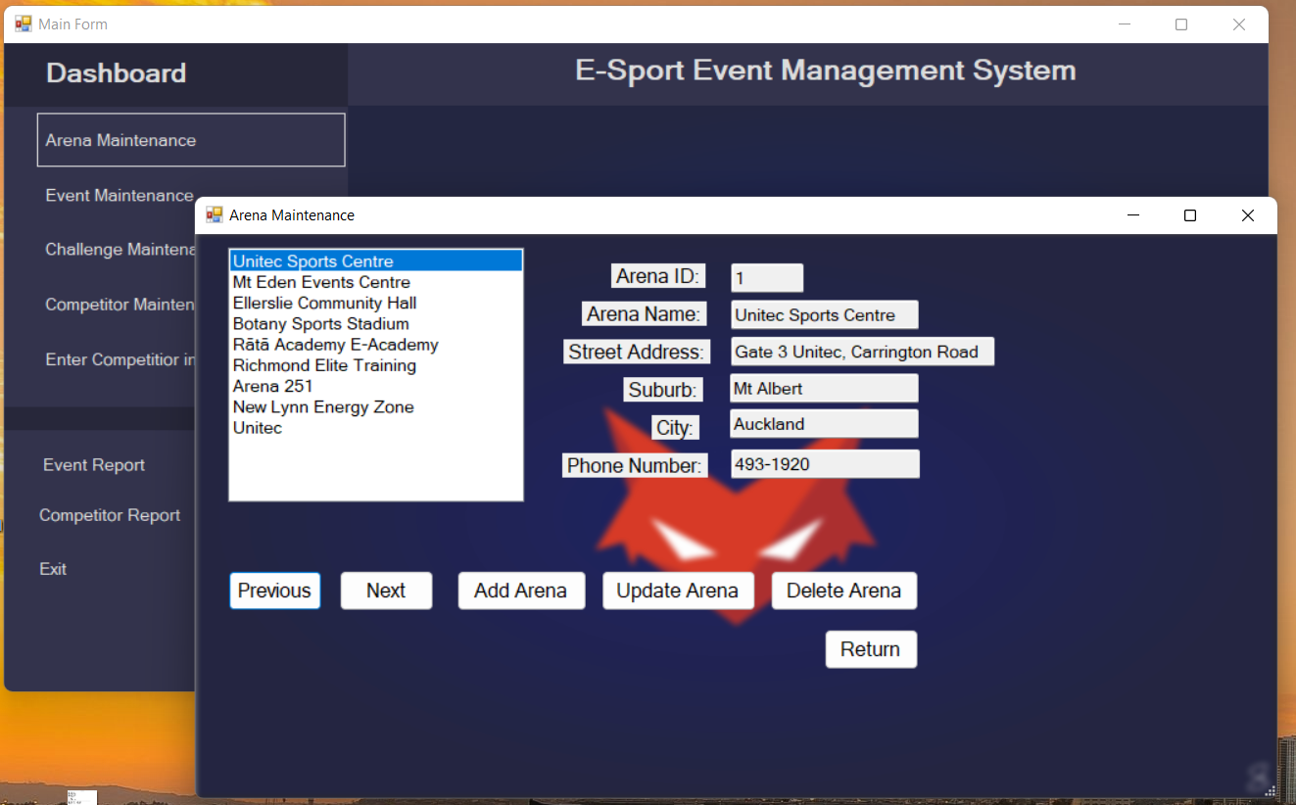

|  |  |  |  |
| --- | --- | --- | --- |
| Requirement to test | Test Data Input | Expected Outcomes | Actual outcomes |
| 1. “Add Arena” Button. | The user clicks on Add Arena Button. | On click, Panel Add Arena is displaced, rest of the buttons are disabled on the Arena Maintenance form. | Same as the expected outcome. |

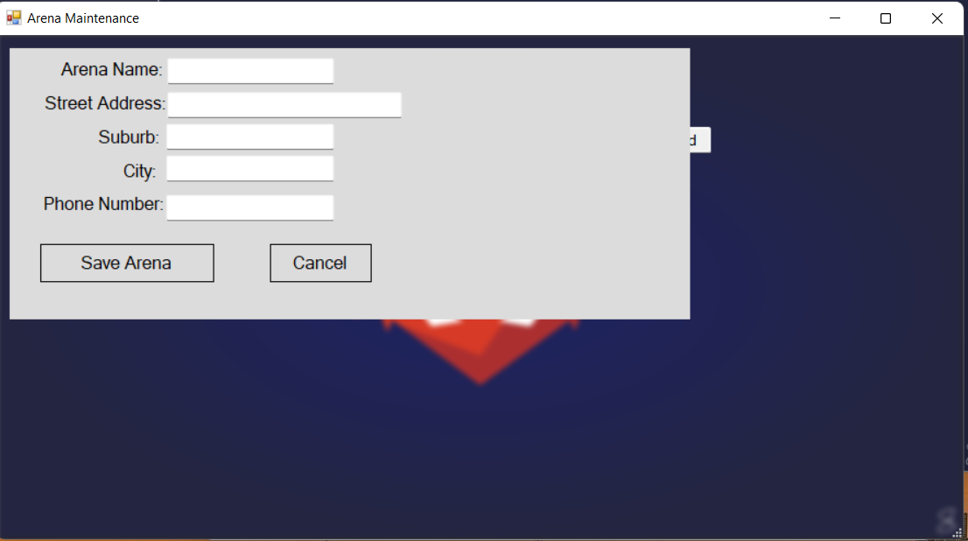

|  |  |  |  |
| --- | --- | --- | --- |
| Requirement to test | Test Data Input | Expected Outcomes | Actual outcomes |
| 1. Add a New Arena record. | User fill details in opened Panel “Add Arena” | Users fill in details and click on save Arena. A New Arena record is Added. Arena Name is displayed in the list box.  A message box is displayed if the user leaves a blank field. | Same as the expected outcome. |

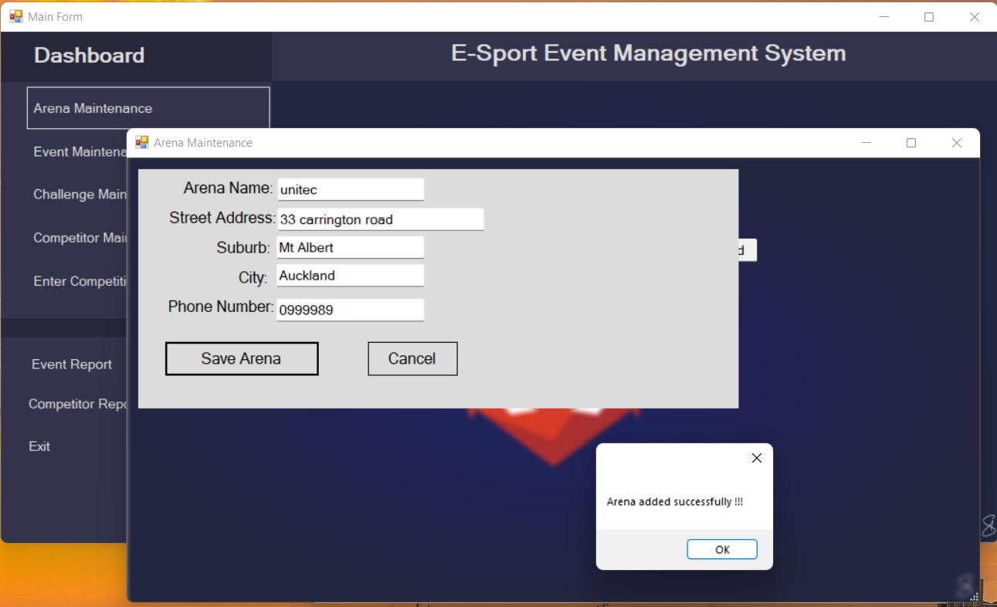

|  |  |  |  |
| --- | --- | --- | --- |
| Requirement to test | Test Data Input | Expected Outcomes | Actual outcomes |
| 1. Update existing Arena Record. | The user clicks on the Update Arena button on the Arena Maintenance form. | Update Arena Panel is displayed, and information is displayed of selected Arena. The user clicks the save changes button and the Message box displays a message and Arena Panel is closed. | Same as the expected outcome. |

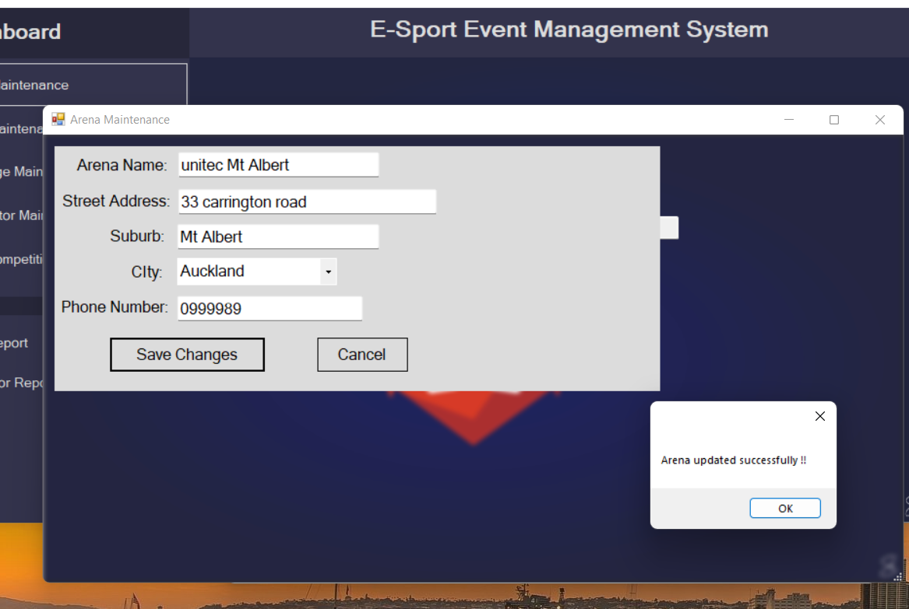

|  |  |  |  |
| --- | --- | --- | --- |
| Requirement to test | Test Data Input | Expected Outcomes | Actual outcomes |
| 1. Delete the Arena record. | The user clicks on the Delete button to delete the selected Arena. | A message box is displayed if Arena has Events Scheduled and delete operation is not performed.  Otherwise, A message box is displayed to confirm the user wants to delete the selected Arena. On click “ok” Arena record is deleted. | Same as the expected outcome. |

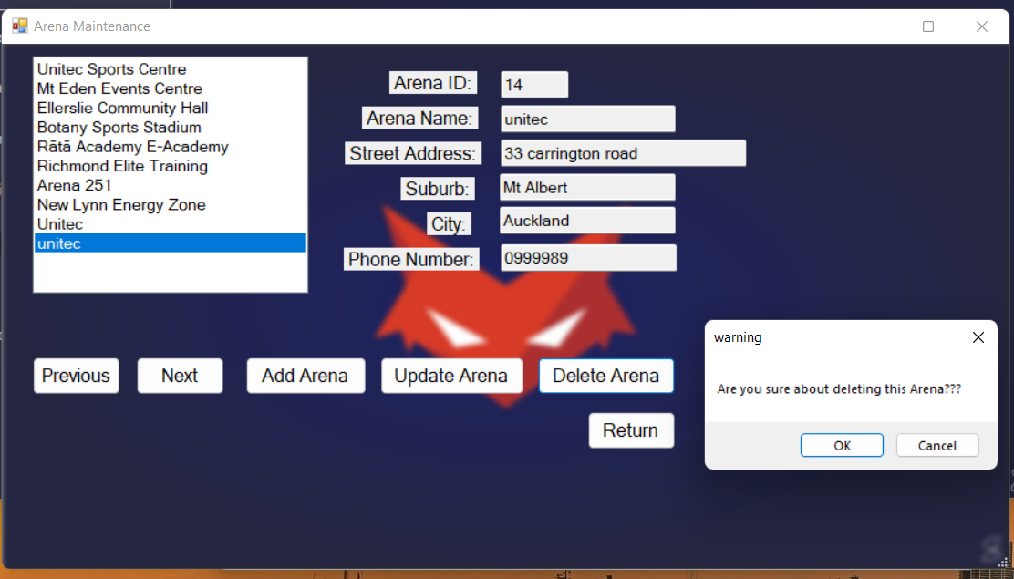

|  |  |  |  |
| --- | --- | --- | --- |
| Requirement to test | Test Data Input | Expected Outcomes | Actual outcomes |
| 1. Attempt to mark as finished an existing completed challenge. | The user clicks on the “Mark Challenge as a finished button” | Challenge Status changes to “Finished” | Same as the expected outcome. |

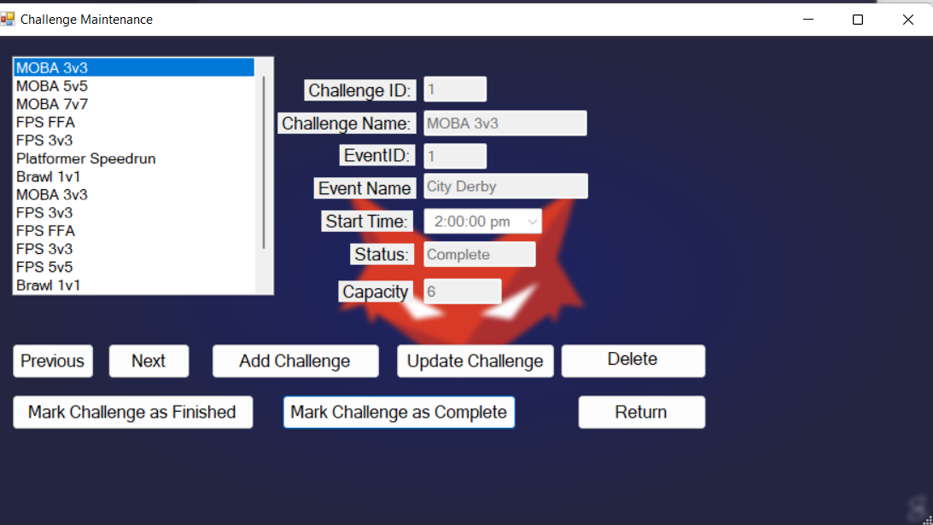

|  |  |  |  |
| --- | --- | --- | --- |
| Requirement to test | Test Data Input | Expected Outcomes | Actual outcomes |
| 1. Attempt to mark as completed an existing scheduled challenge | The user clicks on the “Mark Challenge as a Complete button” | Challenge Status changes to “complete” | Same as the expected outcome. |

|  |  |  |  |
| --- | --- | --- | --- |
| Requirement to test | Test Data Input | Expected Outcomes | Actual outcomes |
| 1. Add a new challenge with valid data in all fields. | The user enters valid data in all fields. | A new challenge will be added to the Challenge list and a Message is displayed “New challenge is added successfully”. Newly challenge added to the Listbox, details displayed when the user clicks on New challenge added in the Listbox. | Same as expected. |

|  |  |  |  |
| --- | --- | --- | --- |
| Requirement to test | Test Data Input | Expected Outcomes | Actual outcomes |
| 1. Update an existing challenge’s capacity with valid data. | The user changes the capacity of the challenge and clicks on the button “save changes”. | A message is displayed “challenge updated successfully”. changes in capacity are saved and Updated. | Same as expected. |

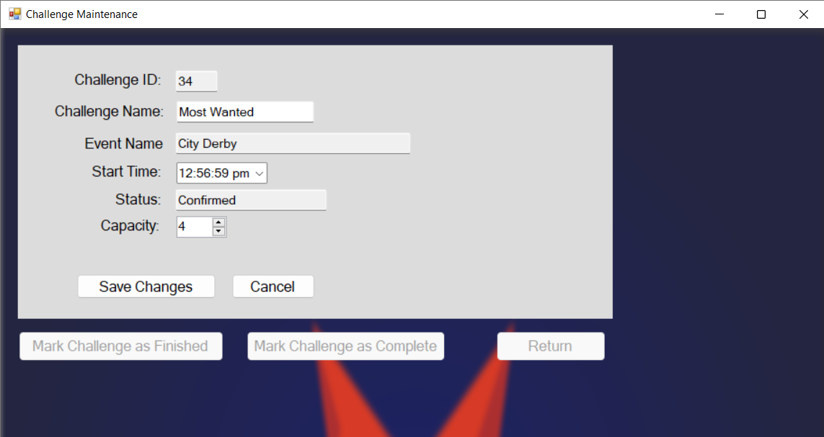

|  |  |  |  |
| --- | --- | --- | --- |
| Requirement to test | Test Data Input | Expected Outcomes | Actual outcomes |
| 1. Update an existing challenge’s name with valid data. | The user changes the name of the challenge and clicks on the button “save changes”. | A message is displayed “challenge updated successfully”. changes in the challenge name are saved and Updated. | Same as expected. |

|  |  |  |  |
| --- | --- | --- | --- |
| Requirement to test | Test Data Input | Expected Outcomes | Actual outcomes |
| 1. Delete an existing challenge that has no entries. | The user clicks on the delete button to delete the selected challenge in the List Box. | Message Box appears to confirm delete operation, if the user clicks ok, the selected challenge is deleted.  If Challenge has associated entities, an appropriate message is displayed. | Same as expected. |

|  |  |  |  |
| --- | --- | --- | --- |
| Requirement to test | Test Data Input | Expected Outcomes | Actual outcomes |
| 1. Add a new event with valid data in all fields. | The user enters valid data in all fields. | A new Event will be added to the Event list and a Message is displayed “New Event is added successfully”. Newly Event added to the Listbox, details displayed when the user clicks on New Event added in the Listbox. | Same as expected. |

|  |  |  |  |
| --- | --- | --- | --- |
| Requirement to test | Test Data Input | Expected Outcomes | Actual outcomes |
| 1. Update an existing event’s name with valid data. | The user changes the name of the Event and clicks on the button “save changes”. | A message is displayed “Event updated successfully”. changes in the Event name are saved and updated. | Same as expected. |

|  |  |  |  |
| --- | --- | --- | --- |
| Requirement to test | Test Data Input | Expected Outcomes | Actual outcomes |
| 1. Update an existing event’s date with valid data | The user changes the date of the Event and clicks on the button “save changes”. | A message is displayed “Event updated successfully”. changes in the Event date are saved and updated. | Same as expected. |

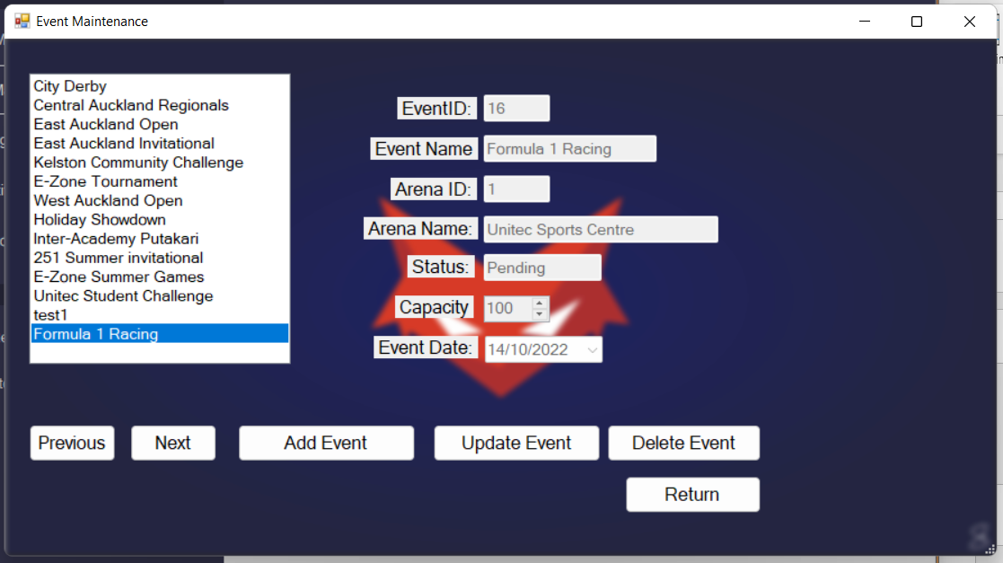

|  |  |  |  |
| --- | --- | --- | --- |
| Requirement to test | Test Data Input | Expected Outcomes | Actual outcomes |
| 1. Delete an existing event that has no challenges. | The user clicks on the delete button to delete the selected challenge in the List Box. | Message Box appears to confirm delete operation, if the user clicks ok, the selected Event is deleted. | Same as expected. |

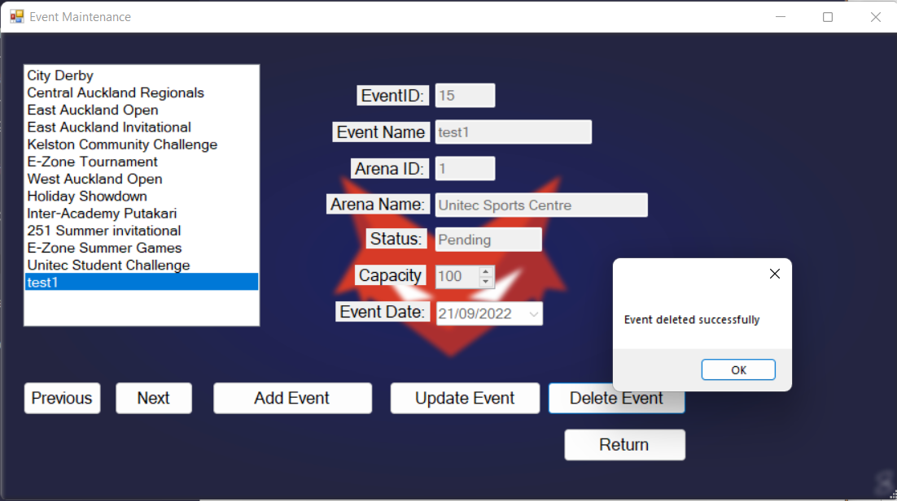

|  |  |  |  |
| --- | --- | --- | --- |
| Requirement to test | Test Data Input | Expected Outcomes | Actual outcomes |
| 1. Attempt to delete an existing event that has challenges | The user clicks on the delete button to delete the selected challenge in the List Box. | If the Event has associated entities, an appropriate message is displayed. | Same as expected. |

|  |  |  |  |
| --- | --- | --- | --- |
| Requirement to test | Test Data Input | Expected Outcomes | Actual outcomes |
| 1. Attempt to add a new event with an invalid name but with valid data in all other fields. | Users skip event names or status of Events to enter. | A message is displayed stating “Mandatory fields are empty” | Same as expected. |

|  |  |  |  |
| --- | --- | --- | --- |
| Requirement to test | Test Data Input | Expected Outcomes | Actual outcomes |
| 1. Attempt to add a competitor to a finished challenge | User tries to add Attempt to add a competitor to a finished challenge through Button Add Entry. | A message is displayed “Cannot add a competitor to finished Challenge” | Same as expected. |

|  |  |  |  |
| --- | --- | --- | --- |
| Requirement to test | Test Data Input | Expected Outcomes | Actual outcomes |
| 1. Attempt to add a competitor to a completed challenge | User tries to add Attempt to add a competitor to a finished challenge through Button Add Entry. | If Challenge has scheduled status, the competitor is added to Challenge and Message is displayed. | Same as expected. |

